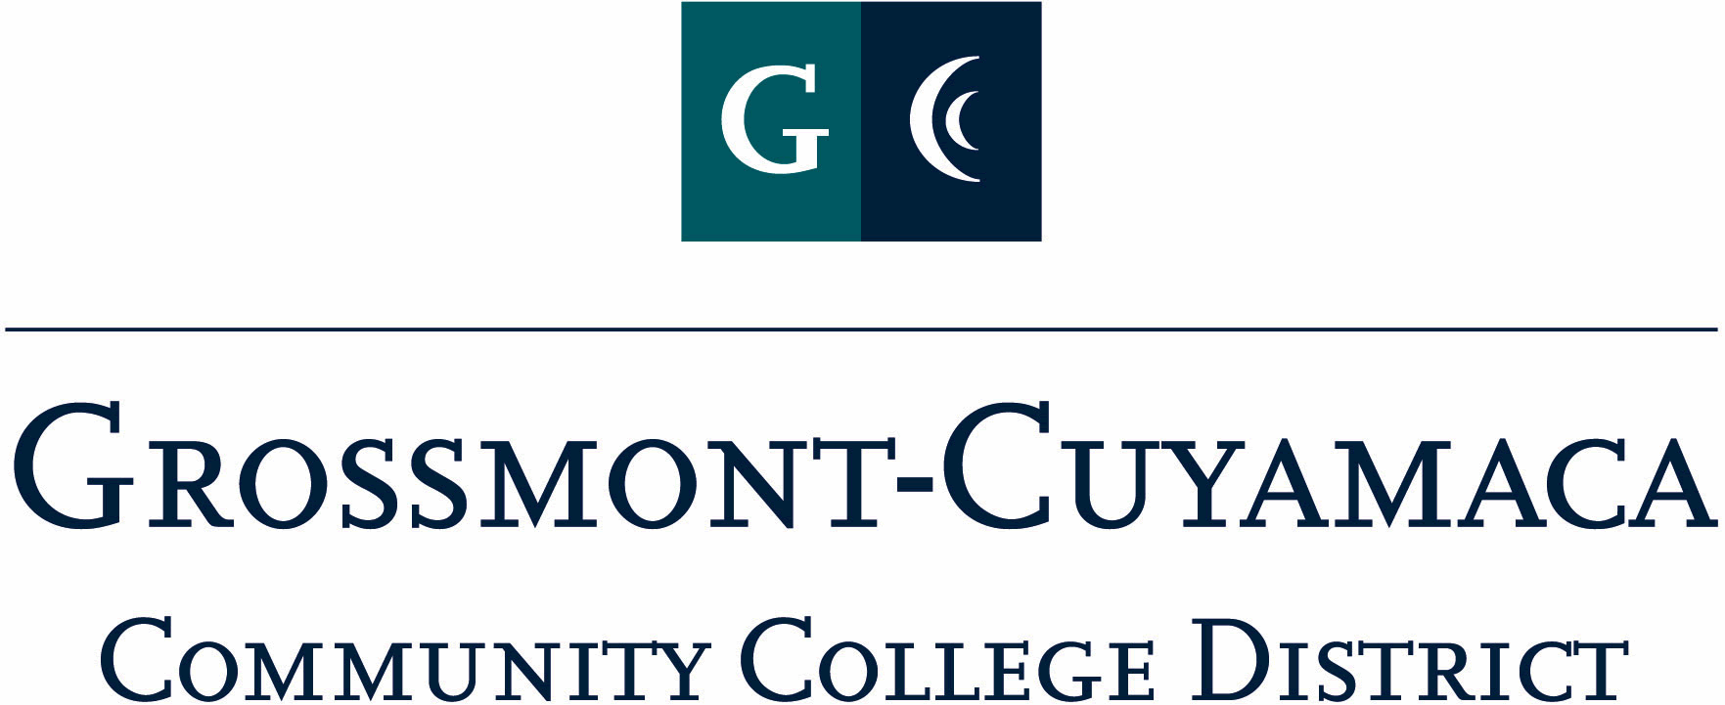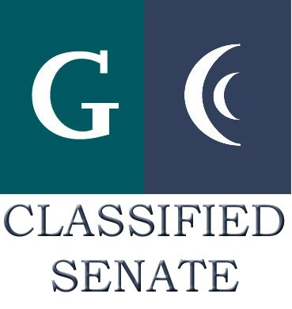
D R A F T
CLASSIFIED SENATE
EXECUTIVE BOARD MEETING
April 13, 2010 – Meeting Minutes

Members Present: Debi Miller, Tasa Campos, Wendy Corbin, Yvette Macy, Maria Briney, Scott Howell, Jacqueline Osborne, Angela Johnson, Pat Murray, Karen Ostegard, Karen McCoy, Jean Wallace, Maggie Gonzales, Avelina Wilder, Kimberly Gioscia
Members Absent: Patricia Bailey
Members Excused: Monica Farris, Paula Tillery

1. Welcome and Call to Order

The meeting was called to order at 12:07p.

2. Approval of Minutes from

The minutes from March 3, 2010 meeting were approved. M/S/A Gioscia/Wilder. Motion passed.

3. Communication

VP Reports

District: Wendy Corbin reported that she attended the April DEC meeting. Welcome of Stuart Savin, new Cuyamaca College President. A new member of the district staff will be approved at the April Board meeting, Director of Employee & Labor Relations. At the meeting there was discussion on Board policies, specifically concerning field trips for students. There is also a push for Emergency Preparedness training in response to Accreditation.

Grossmont: Pat Murray reported out that Grossmont will be submitting their final draft of their Accreditation Midterm Report next month and will be going to the Governing Board in June. She added that the “Kudos” awards are ongoing and the cut off for nominations is April 30. The Health Science area will be moving into their new building in mid-May and then the current building will be remodeled for Student Services to accommodate the remodeling of Administrative Offices over the summer.

She informed the group of the information shared at the Grossmont Leadership Meeting and trying to adhere to the state restrictions on cap for next year at cap + 5%. Faculty are instructed to not go over class max.

The Ethics Statement for Grossmont College as proposed by Vice President of Student Services, Dr. John Colson was presented to this body for review, Pat moved to approve the Ethics Statement proposal. M/S/A Murray/Wallace. Motion passed.

She added that Vice President for Academic Affairs forums are coming up and encouraging staff to attend. She was also asked to participate in the President’s evaluation process with input from classified staff.

Cuyamaca: Maggie Gonzales reported out that Cuyamaca College President, Stuart Savin, started this month. She also added that the Accreditation Midterm Report is going to the Innovation & Planning Council for a first read this month.

President’s Report:

CSAD Debriefing Meeting: President will send out e-mail checking availability of the group to hold the debriefing meeting on 4/29.

Chancellor Classified Senate Award: President informed the group that the award will now reflect the approved district-wide strategic plan values.

Due to Pat Murray’s resignation from this review committee, a new member is needed on the committee, currently they meet once a quarter. The next meeting is scheduled for June, 2010. Jean Wallace volunteered with Yvette Macy as a back-up.

President, Debi Miller, announced that she would absent from the June Executive Board meeting and Governing Board meeting and was requesting representation from the group for these events. Maggie Gonzales will chair the June 8 Executive Board meeting and Pat Murray will represented Classified Senate at the June 15 Governing Board meeting.

Treasurer Report: Paula Tillery was unavailable for the report. Will bring back to next meeting.

4. Continuing Business

Ratify C&Bs: The President shared the results of the voting from the membership on March 29, 2010. The changes to the C&Bs passed, and the Classified Senate E-Board ratified the changes unanimously. M/S/A Murray/Corbin. Motion passed.

Padre Survey Results: The group discussed the results from the recent Padre Fundraiser survey results. There was an extensive and lengthy discussion on the issue. The group included exploring new ideas on how to approach the fundraiser so it would not be such a time burden on already overburden staff and to place on the upcoming Retreat agenda for new ideas and approaches. One of the suggestions from Scott Howell was to hold the event as a benefit instead of a fundraiser due to the dismal results of the survey. It was suggested a small committee be developed to review possible options. There were no volunteers to chair and handle the committee. Motion to NOT participate in the Padre Fundraiser starting 7/1/10. M/S/A Campos/Howell. Motion passed.

A motion was made to organize a committee to be in charge of the Padre event as a benefit and not a fundraiser. The motion was withdrawn.

Debi Miller will check with other constituenty groups and the Foundations to see if there is any interest and report back.

5. Fundraising Activities:

See’s Candy: The final profit off of the Spring 2010 See’s Candy fundraiser was $289.60. Pat Murray suggested that in the future at the top of the form that a room # box be included, so those delivering the candy know where to deliver it to.

Cookbook: The current profit off of the Spring 2010 Cookbook fundraiser was $456.00. The President will send out a Cookbook flyer to the district letting them know this fundraiser is still active and Cookbooks are available. The following people will have Cookbooks at their desk to sell and included on the e-mail as the contacts: Maggie Gonzales, Pat Murray, Maria Briney, Karen Ostegard, Karen McCoy, Kimberly Gioscia and Wendy Corbin.

6. Governance:
7. New Business:
8. Other

The meeting adjourned at 12:55p.

